# UNO R3 ULTIMATE KIT User Guide

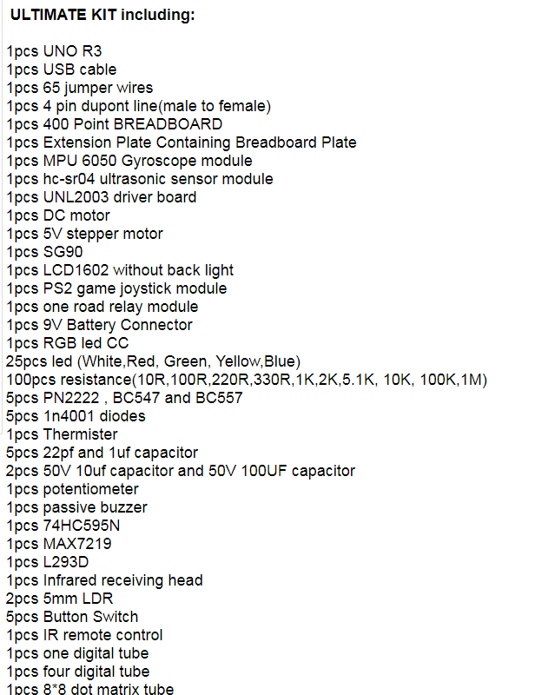

 (UNO R3)

The Arduino UNO is the best board to get started with electronics and coding. If this is your first experience tinkering with the platform, the UNO is the most robust board you can start playing with. The UNO is the most used and documented board of the whole Arduino family.

## Getting Started with Arduino UNO

**Document index：**

**<https://www.arduino.cc/en/Guide/ArduinoUno>**

**Software development tools download index:**

<https://www.arduino.cc/en/Guide/ArduinoUno>

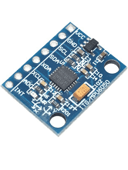**(MPU 6050 Gyroscope module)**

**Reference index:**

<https://lastminuteengineers.com/mpu6050-accel-gyro-arduino-tutorial/>

<https://www.youtube.com/watch?v=wTfSfhjhAU0>

#### IMG_256**(HC-SR04 Ultrasonic Sensor)**

**Reference index:**

<https://components101.com/sensors/ultrasonic-sensor-working-pinout-datasheet>

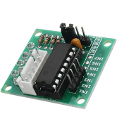(UNL2003 driver board)

**Reference index:**

<https://datasheetspdf.com/datasheet/UNL2003.html>

<https://www.makerguides.com/28byj-48-stepper-motor-arduino-tutorial/>

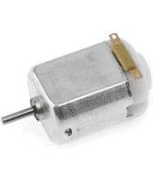**(DC MOTOR)**

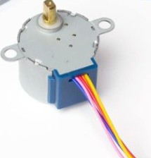(stepper motor)

**Reference index:**

**<https://www.makerguides.com/28byj-48-stepper-motor-arduino-tutorial/>**

<https://www.electronics-tutorials.ws/io/io_7.html>

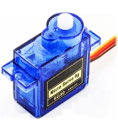**(SG90)**

**Reference index:**

**<https://datasheetspdf.com/pdf/791970/TowerPro/SG90/1>**

**<https://www.electronics-lab.com/project/using-sg90-servo-motor-arduino/>**

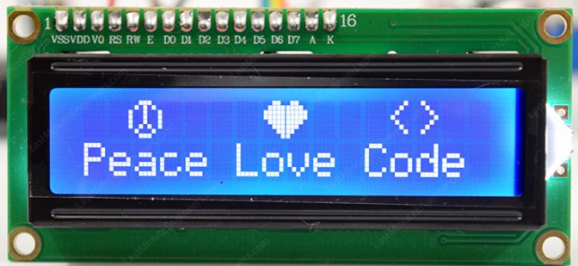(LCD1602)

**Reference index:**

<https://lastminuteengineers.com/arduino-1602-character-lcd-tutorial/>

<https://www.youtube.com/watch?v=S4ya3Q7uhJs>

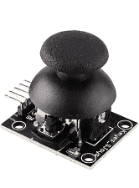**(PS2 game joystick module)**

**Reference index:**

**<https://arduinomodules.info/ky-023-joystick-dual-axis-module/>**

**<https://www.youtube.com/watch?v=MlDi0vO9Evg>**

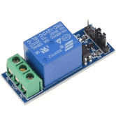**(one road relay module)**

**Reference index:**

**<https://lastminuteengineers.com/one-channel-relay-module-arduino-tutorial/>**

**<https://www.youtube.com/watch?v=7tUGUXyloXQ>**

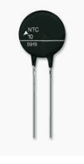(Thermister)

**Reference index:**

**<https://www.engineersgarage.com/electronic-projects/heat-sensor-using-thermister/>**

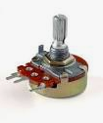(potentiometer)

**Reference index:**

<https://www.arduino.cc/en/tutorial/potentiometer>

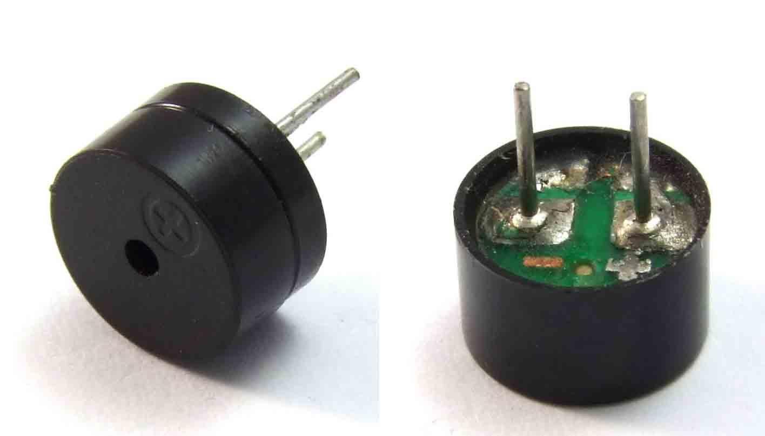 （passive buzzer）

**Reference index:**

<https://www.youtube.com/watch?v=dHYKRrlPNzM>

<https://bgsu.instructure.com/courses/1157282/pages/tutorial-passive-buzzer>

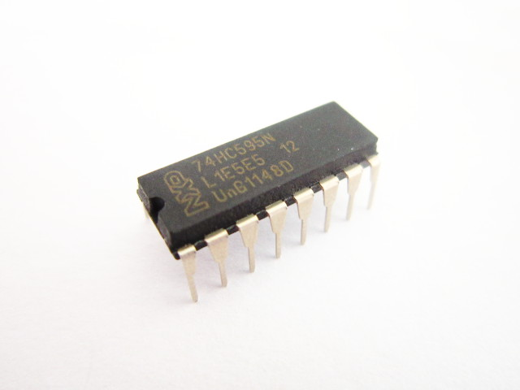**（74HC595N）**

**Reference index:**

**<https://www.youtube.com/watch?v=J5fPA0L4ydE>**

**<http://blog.davidecoppola.com/2013/08/using-a-shift-register-74hc595n-with-arduino/>**

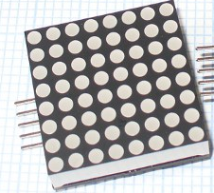**（MAX7219）**

**Reference index:**

**<http://blog.davidecoppola.com/2013/08/using-a-shift-register-74hc595n-with-arduino/>**

**<http://blog.davidecoppola.com/2013/08/using-a-shift-register-74hc595n-with-arduino/>**

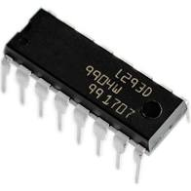**（L293D）**

**Reference index:**

**<https://www.arduino.cc/documents/datasheets/H-bridge_motor_driver.PDF>**

**<https://www.youtube.com/watch?v=jAmDliHcTJ0>**

**Data Search index:**

**<https://www.designfast.com/?campaignid=11598516368&adgroupid=118743917731&adid=479139353977&gclid=EAIaIQobChMIhaHhz6Dh8AIVtyCtBh0zOQAfEAAYASAAEgKwpvD_BwE>**

**<http://www.datasheetcatalog.com/>**

**<https://create.arduino.cc/projecthub/projects/tags/arduino>**